# 

**SCD Modernization Program**

**Data Model**

**V3.0**

November, 2013

Table of Contents

1. Project Explorer Tables 3

1.1 ERD 4

1.2 Tables Definition 4

1.2.1 Hierarchy 4

1.2.2 FolderNote 5

1.2.3 NoteType 5

1.2.4 FolderCertificate 6

1.2.5 Project 6

1.2.6 ProjectVersion 7

1.2.7 ProjectVersionContent 7

1.2.8 MSKUGroup 8

1.2.9 ProjectMultiSKU 8

1.2.10 ProjectSynchronization 8

1.2.11 SynchronizationType 9

2. Activities and Error tracking 9

2.1 TBD - Eli 9

2.2 Tables Definition 10

3. Messages & Error Handling 10

3.1 ERD 10

3.2 Tables Definition 11

3.2.1 MessageType 11

3.2.2 Messages 11

4. Security 11

4.1 ERD 11

4.2 Tables Definition 11

4.2.1 Privilege 11

4.2.2 Profile 11

4.2.3 ProfilePrivilege 11

4.2.4 UserProfile 11

# Project Explorer Tables

## ERD

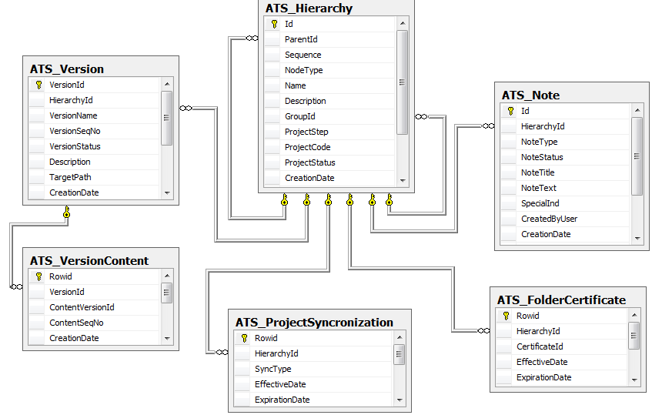

## Tables Definition

### ATS_Hierarchy

Hierarchy tree definition

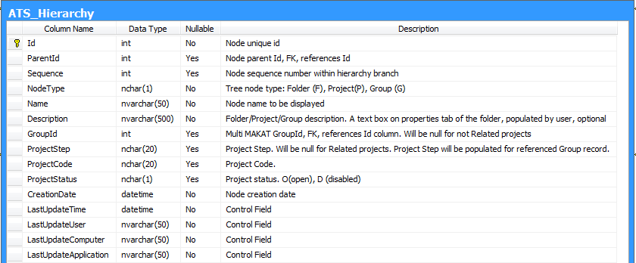

### ATS_Note

Notes

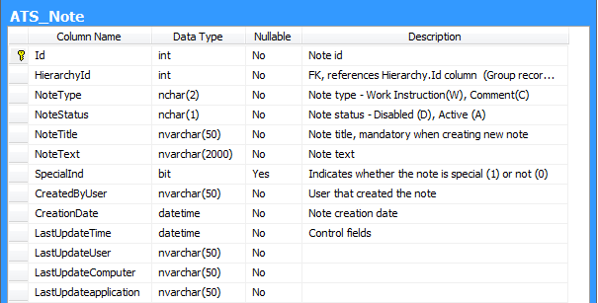

### ATS_NoteType

Reference table, describes various note types

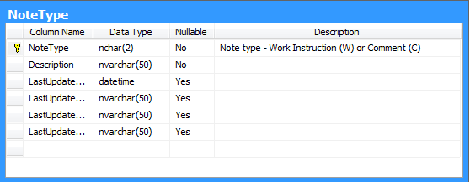

### ATS_FolderCertificate

Certificates assigned to the hierarchy node

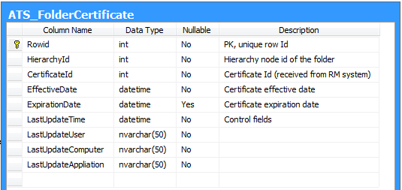

### ATS_Version

Versions management

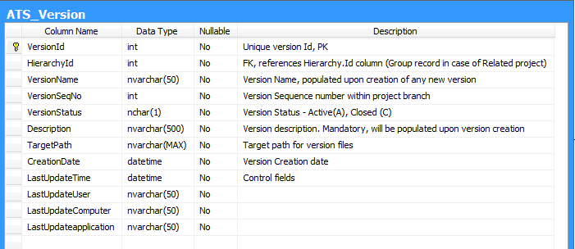

### ATS_VersionContent

Content assigned to version

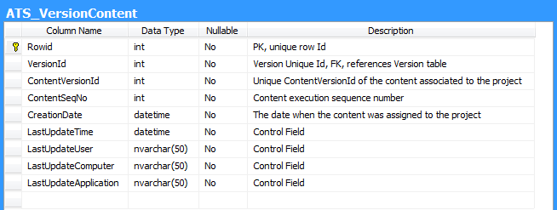

### ATS_ProjectSynchronization

The table contains projects that will be synchronized with another system.

Multiple synchronization types will be defined (SCD USA< Evaluation, etc.)

### ATS_SynchronizationType

Reference table, describes various synchronization types. Only SCD USA type will be implemented in Phase 1.

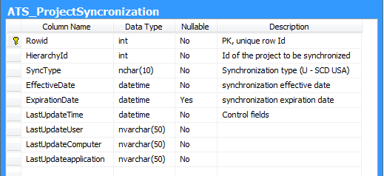

# Activities and Error tracking

## TBD - Eli

## Tables Definition

# Messages & Error Handling

## ERD

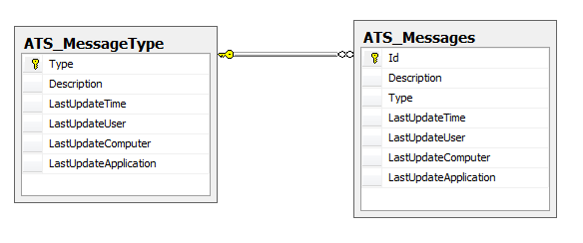

## Tables Definition

### ATS_MessageType

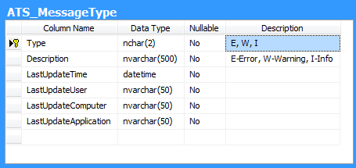

### ATS_Messages

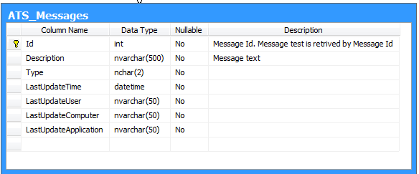

# Security

## ERD

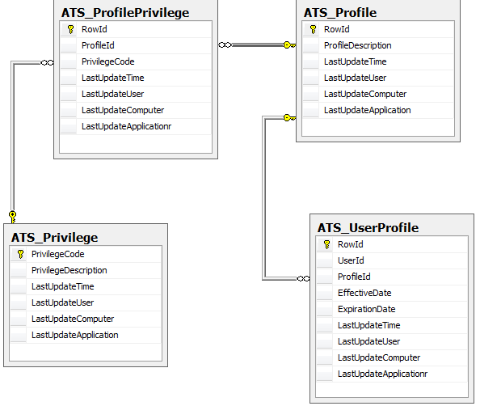

## Tables Definition

### ATS_Privilege

### ATS_Profile

### ATS_ProfilePrivilege

### ATS_UserProfile